Purpose of this document
This document describes the client side of the Secure FTP solution. It contains both prerequisites and
Guide lines on how to use it.

Prerequisites
In order to connect to the Secure FTP Solution, some prerequisites must be in place:

- An FTP client which supports explicit FTPS and user certificates
- A valid M-OCES or V-OCES certificate issued by DanID
- Danish companies only:
  - To access the production FTP-gateway you need to grant access to each certificate in NTSE security administration module. A guide on this can be found at http://www.skat.dk/getFile.aspx?Id=78326 or you can read the NTSE help pages at http://www.skat.dk/getFile.aspx?Id=85571
In this sample the product SmartFTP has been used. There is no recommendation in this product. SmartFTP is a functional client. The configuration of this client will be explained in detail in appendix A.

Conventions
The following conventions are used:

- File- and path names are written in bold
- Other names are written in italic

Generic configuration

- The protocol of the client should be set to use FTP over SSL, Explicit mode.
- An OCES certificate should be chosen as the used login credentials.
- As the username and password are not used, any will do. Note here, that anonymous login is fine, but not sending the information will result in an error.

Usage

Inbound files for a Backend System / Business Service

Connect
Connect to the server using the generic configuration description from above and
login informations from Appendix B – Connection and login information.
Your root directory will be your RID or UID number from your certificate e.g.
UID_1282307246937
RID_1282307246937

Change directory
Change directory to the relevant Backend System / Business Service. For ICS this is either of the following:

- /SUMMARISKINDGANGSANGIVELSEOPDATERSERVICE
- /SUMMARISKINDGANGSANGIVELSEOPRETSERVICE
- /SUMMARISKINDGANGSANGIVELSESAMLINGOMDIRIGERSERVICE

Upload
In this directory upload the file for the Backend System / Business Service. Two transaction identification mechanisms is used in the communication and both will be included in the status-files returned by the FTP-gateway:

- FTPTransactionID
  - This is equal to the filename of the uploaded file and must be unique within SKAT scope. Example: “DK315,EORI-DK12345678,UID-1234567891234,2010-09-01T01:23:45.678+01:00.xml”
- SKATTransactionID
  - This is set in the hovedoplysninger-tag (maininformation-tag) within the uploaded xml-file and used as the transaction id of the service call to the Backend system / Business service.

The hovedoplysninger-tag is structured as specified in the wsdl-files for the above services. Below is an example of this structure.

<ns:HovedOplysninger>
<ns:TransaktionIdentifikator>EORI:DK12345678,UID:1234567891234
</ns:TransaktionIdentifikator>
<ns:TransaktionTid>2010-09-01T01:23:45.678+01:00</ns:TransaktionTid>
</ns:HovedOplysninger>

It is highly recommended populate hovedoplysninger with relevant identification data (EORI, Certificate-UID, generated GUID or similar) like above. Any information below 100 chars can be set in the element TransaktionsIdentifikator.

Note that as soon as the upload has finished, the file will be moved for processing in ICS.
This might yield an error if the client tries to check the file size, but this error can safely be ignored.

Response
After ICS has processed the file you can find a status file in the <root folder>/out directory.
This directory will contain a file called status_<requestedservice>_<FTPTransactionID>.xml which contains information on whether the file was successfully delivered to the Backend System / Business Service or an error occurred. A status file will be exposed for download in these three scenarios:

- File has been sent to requested Backend System / Business Service.
- Requested Backend System / Business Service has successfully accepted the file.
- An error has occurred.

Out folder
The <root folder>/out directory should be polled regularly for further responses from the Backend
System / Business Service. These will likewise be accompanied by a status file.

Outbound files from a Backend System / Business Service
When a Backend System / Business Service sends outbound files, these will also be placed in <root folder>/out. Each company will have its own <root folder>/out folder on the FTP-gateway.

Appendix A – SmartFTP configuration
The SmartFTP client can be downloaded from http://www.smartftp.com. A default installation should
be performed.

Configuration in SmartFTP:
- Go to the Favorites/Edit Favorites window.
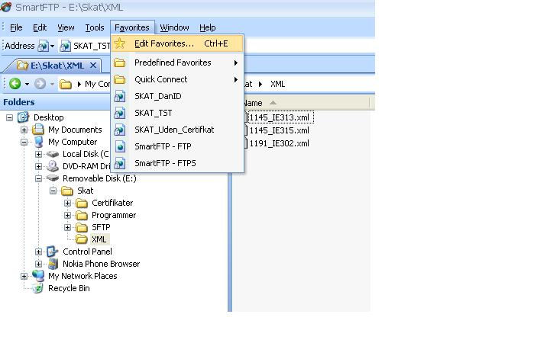
Figure 1 Edit favorites

Click Favorite/New/Favorite.

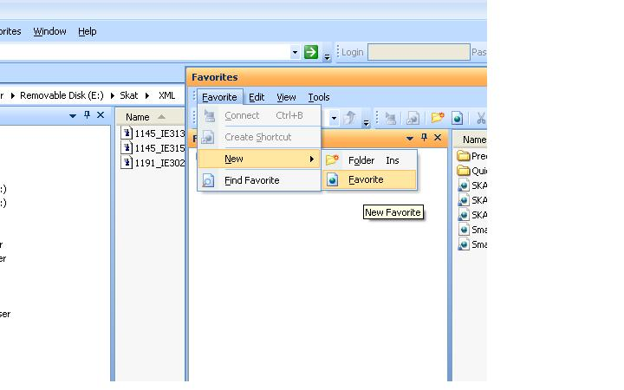
Figure 2 Create new favourite

Under General specify a favorite connection. The connection will be identified by
what is written in Name. It is important to choose FTP over SSL Explicit as Protocol,
and to choose Anonymous as Login Type.

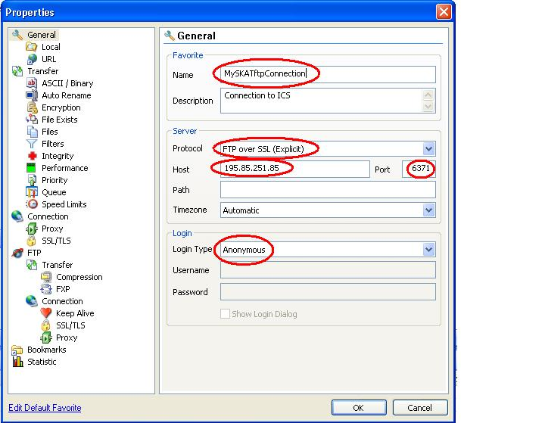
Figure 3 SmartFTP favorites settings

Go to FTP/Connection/SSL/TLS. Make sure that the following options are set:
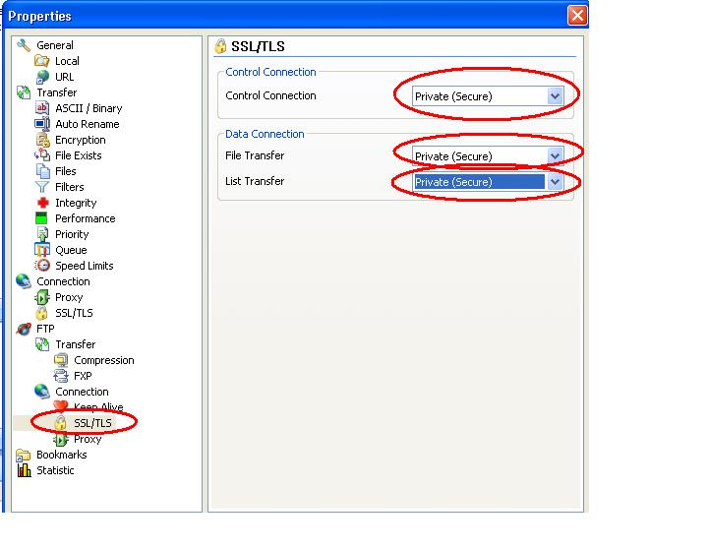
Figure 4 SmartFTP certificate setup

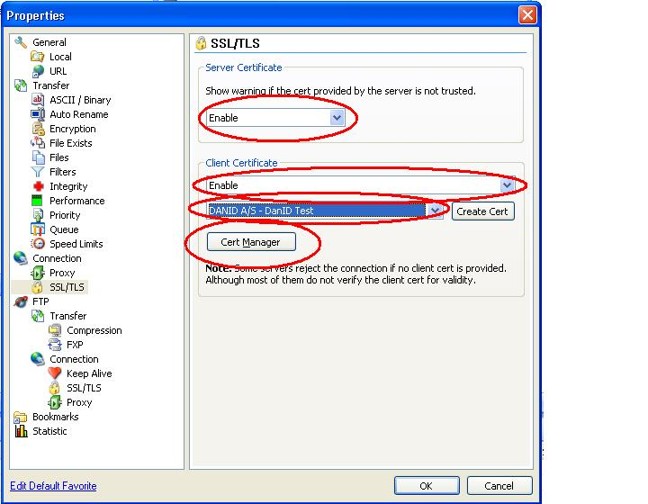

Note that Show server cert warning should be set to enable in a production system.

Click the Cert Manager button to manage certificates in SmartFTP.
If no valid DanID OCES certificate exists in the manager, click Import….
Follow the guide, choosing your own DanID OCES certificate.
When the certificate is imported successfully, it should appear in the Personal tab.
Close the certificate manager and choose the OCES certificate next to the Create Cert
button.
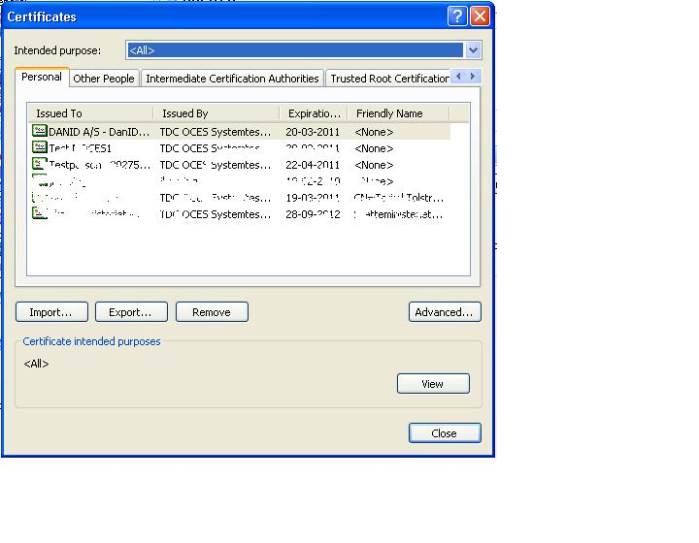
Figure 5 Installed certificates
Click OK to close the properties dialog.

Launch your created connection by double clicking it in the Favourite window and press “Yes” in the warning window.
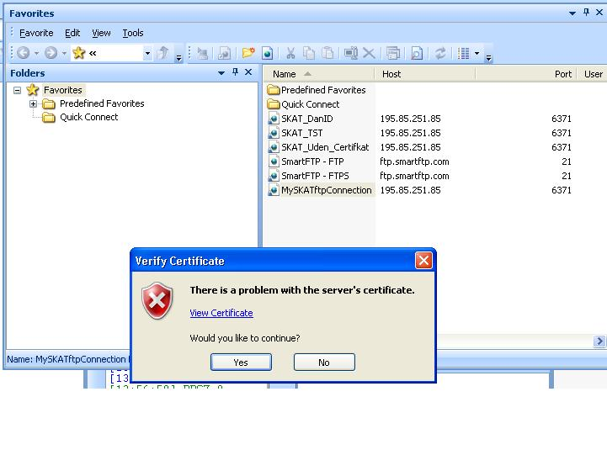

You should now be able to up and download files.
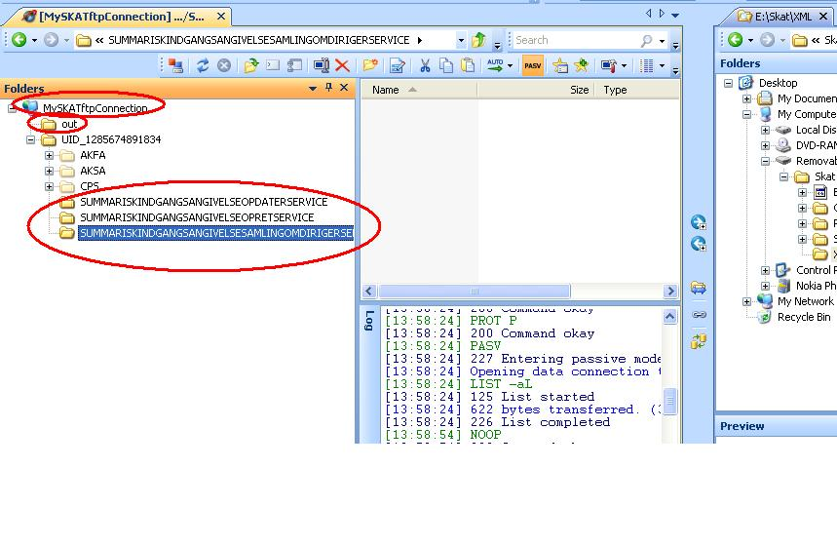

6. Appendix B – Connection and login information

Test system:
IP address of the Gateway server:
secureftpgatewaytest.skat.dk (195.85.251.85)
Port number on the Gateway server for inbound FTP connections:
6371
Port range on the Gateway server for inbound FTP data connections:
35000 - 35010
Login:
Any username/password or anonymous.
Certificate:
Use a valid company OCES certificate.

Production system:
IP address of the Gateway server:
secureftpgateway.skat.dk (195.85.251.102)
Port number on the Gateway server for inbound FTP connections:
6371
Port range on the Gateway server for inbound FTP data connections:
35000 - 35100
Login:
Any username/password or anonymous.
Certificate:
Use a valid company OCES certificate.

7. Appendix C – Description of status file
One purpose of the status file is to inform what has occurred to the uploaded file. If the
client has made a mistake, the status file will hold information of the error and what action needs to be
taken to resolve it. Likewise, if a system error occurs or if the file flow has completed successfully, the
client will be informed accordingly. Secondly, the client will receive a status file whenever a Business
Service has finished a file transfer, containing details on whether this is a reply or not, and which files
have been made available.
The status file contains information identifying the specific transaction to the client:
The called service, the selected transaction ID, the uploaded file name, the SKAT transaction ID and
the time of the status file. The format of the status file is detailed in the appropriate XSD
[status_file.xsd].

The elements in the status files are:
Filename |  | Name of the uploaded file by the client. Can in theory be omitted if status file is for an outbound file that is not a response to a previously uploaded file.
FTPTransaktionsId |  | Unique transaction ID as specified by the client
SKATTransaktionsId |  | Unique transaction ID generated by the system
Timestamp |  | Timestamp of the status file
status.code |  | Status code. Can either be OK or ERROR
Service |  | Requested backend system
response | filename | List of files exposed to the client. This will only be included if status file is for one or more outbound files.
Error | error.code | Unique code for a specific error
Error | error.message | Description of the error
Error | error.resolution | Description of a possible solution

